A Rule-Based Music Recommendation System Based on Depression Levels of User Posts Extracted from Social Networks

# Md Ashed Dewan

# Dept. of Computer Science and Engineering

# Aliah University,

# Kolkata India,

# ashad.ad13946@gmail.com

**Abstract— Statistics presented by the World Health Organization find depression as a primary cause of anxiety worldwide, leading to suicide in most cases if left undiagnosed Studies show that depression affects writing style and associated language use. The primary goal of the proposed research is to study users' posts on Twitter and find symptoms of online users that may show depression. Deep learning methods and natural language processing techniques are employed for the paper to train our data and evaluate our proposed model. The tweets detected sentiment through long short-term memory network. Evaluate our model we get 82% accuracy. The method proposed a numerical score for each user based on the sentiment value of their tweets and predict sentiment is depress or not. If user tweets predict depress then our knowledge base recommendation model recommended a positive song.**

I. INTRODUCTION

Women are more likely than men to experience depression, according to a survey done in September 2021 and published by the World Health Organization (WHO) (<https://www.who.int/news-room/fact-sheets/detail/depression>). According to Mind Journey, a mental health organization and online counselling service, 4.5% of adults in India would have a mental health condition by 2022. Depression typically has sadness and a loss of interest as its primary causes. Hence, early diagnosis of depression is essential for successful therapy. It is concerning that people frequently choose not to seek professional assistance or advice from a mental health professional due to the social stigma associated with having protracted depressive symptoms [1].

Social networks are a trendy way to share knowledge, ideas, and life experiences, and people use them to express themselves. Users post statements on social media sites using either good, negative, or neutral emotions to express their ideas. In this context, the level of research sentiment towards the subject has begun to emerge. Learning more about a circumstance, object, or piece of content made easier and more expressive by being aware of the emotional impact of a sentence. E-learning, e-commerce, and multimedia are just few of the businesses that may apply sentiment analysis, a text analysis and natural language processing approach [2, 3]. Yet, it is still challenging to employ it in recommendation systems. generating sound recommendations based on feelings.

Twitter is currently the social media platform most frequently used for sentiment analysis research. Researchers believe that analyzing tweets from Twitter may be able to detect sadness and other mental health conditions. The development of novel, innovative healthcare therapies and systems for the early diagnosis of depression is inspired by these online activities. This online activity inspires them to develop cutting-edge technologies for the early identification of depression and potential medical treatments. This done by utilizing a deep learning system that combines long short-term memory (LSTM) and natural language processing (NLP) techniques to identify melancholy in user messages [1].

Our main goal is to employ LSTM and NLP to suggest music to the user. People emotional, cognitive, physical, and social demands might be satisfied with the use of music therapy. It is a form of psychotherapy that uses music to improve relationships, promote happiness, and manage stress, anxiety, and depression. Music therapy can be an effective depression treatment because it provides people with a safe, non-intrusive avenue for expressing and processing difficult emotions and because it promotes the creation of brain chemicals that control mood. You can combine it with other treatments for the greatest outcomes.

For the suggested system, we create a recommend engine that analyses a small sample of tweets from a single user and determines the sentiment of those tweets, either positive or negative, using our sentiment model. We place the person in the neutral category if they experience an equal amount of pleasant and negative emotions. The stronger emotion is shown if a user's sentiment is out of balance and recommend a positive song.

# II**.** RELATED WORK

In this paper [4] authors implications of hyper-parameter tuning and how it might be useful for depression research on a small Bangla social media dataset are demonstrated. The outcome demonstrates that for stratified datasets with recurrent sampling, excellent depression detection accuracy can be achieved using 5 layered LSTMs of size 128 with batch sizes 25 and learning rates of 0.0001 across 20 epochs.

In this paper [5] authors investigated word embedding models (Word2Vec, Glove) in tweets using deep learning techniques to identify sentiment polarity. Here, by including memory in a network model for prediction and visualization, we investigated how sentiment analysis using the recurrent neural network (RNN) model and long-short term memory networks (LSTMs) units can handle long-term dependencies.

The authors of [6] conducted a Chinese depression analysis. They blended psychological and machine learning expertise in their work. With the assistance of psychologists, the authors chose 90 depressed and 90 non-depressed Sina Microblog users, gathering a total of 6013 microblogs. Their model's accuracy was 80%.

In this paper [7] the authors' major focus in this study is on a combined task that combines targeted aspect-based polarity classification with target-dependent aspect detection. Using two benchmark datasets, the effectiveness of the suggested strategies is assessed for this collaborative effort. The experiment demonstrates that in two targeted aspect sentiment tasks, the suggested attention architecture and knowledge-embedded LSTM might outperform cutting-edge techniques.

In this paper [8] authors of this study investigate a novel use of recursive neural networks (RNN) coupled with deep learning for sentiment analysis of reviews. By examining various reviews and subsequently generating a score based on them, the proposed RNN-based Deep-learning Sentiment Analysis (RDSA) recommends locations close to the user's present location.

The authors of this paper [9] describe an enhanced sentiment metric (eSM), which combines a lexicon-based sentiment metric with a user profile-based correction factor, to create a music recommendation system based on sentiment intensity metrics.

In this article [10], a hybrid recommendation system for movies is proposed. It makes use of the most effective ideas from CF and CBF as well as sentiment analysis of tweets from microblogging websites. The goal of using movie tweets is to comprehend current trends, popular opinion, and user reaction to the film.

In [11], a social user recommendation system is constructed to present a list of individuals who share similar interests. The stated weighting function considers the user's sentiment towards concepts from tweets. The Sentiment-Volume-Objectivity (SVO) function creates detailed user profiles for use in the recommendation process. Even though people have similar interests, they may have differing perspectives on them. Hashtags used to denote topics in tweets from the 2013 Italian election. The SVO function is defined for a user and tied to a notion. The sentiment component is based on positive and negative tweets related to an idea. The volume denotes how much a user writes about an idea, but the objectivity represents how many Twitter tweets can be classified as objective concerning a concept.

We discover that most of the studies employed sentiment analysis and the recruiting system individually in all of the aforementioned articles. In our article, we incorporate both emotional analysis and a recommendation system. we began with tweet preprocessing and then used the LSTM model to predict tweet sentiment. Next, we aggregated the data and fed it into the recommendation engine, which returned a list of potential songs based on the user's sentiment.

# III**.** PROBLEM STATEMENT

Some objectives for this problem statement could include:

Identifying the sentiment of user-generated text data (such as reviews or ratings) to understand user preferences and help recommend music that is likely to be well-received by the user.

Developing a machine learning model that can accurately classify the sentiment of text data and use this information to make recommendations to users.

Evaluating the effectiveness of the recommendation system in terms of user engagement, retention, and other relevant metrics.

Investigating ways to improve the performance of the recommendation system, such as by using word embeddings or other techniques to better capture the meaning of text data.

Overall, the goal of a music recommendation system based on sentiment analysis would be to use the sentiment of user-generated text data to personalize the recommendation process and improve the user experience for a music streaming service.

# IV**.** PROPOSED METHODOLOGY

We suggest utilizing machine learning and deep learning on a particular characteristic model for categorizing sadness in individuals due to the varied user behaviors on social media and the intricacy of their postings. The model requires three inputs. Each user's tweet, employing a variety of linguistic characteristics, serves as the initial input. utilizing a range of linguistic elements. Data on recommendations is the others input. The data feature output that our prediction model received was In the next sections, which outline our methodology, data preparation, analysis, classification, recommender systems, and output are all demonstrated.

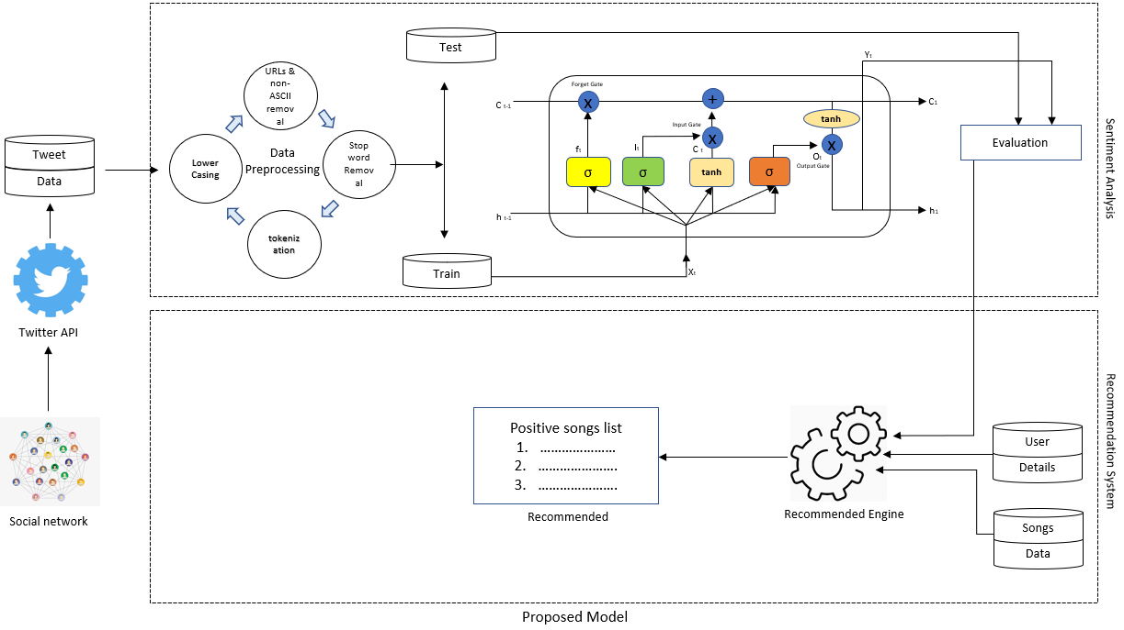

# Data Acquisition

The suggested approach trains algorithms for depression identification using Twitter data. A list of depressive quotes was initially created from depressive subreddits where individuals asked for help from the internet community. These articles are frequently authored by depressed individuals; therefore, it is possible to view them as depressing assertions. Standard postings about friends, family, or entertainment are also gathered from other subreddits. A selection of words that are subsequently utilized as search terms on Twitter are developed after carefully reviewing postings that are relevant to depression.

|  |  |  |
| --- | --- | --- |
| Description | Depressed Dataset | Non- Depressed Dataset |
| Twitter users | 445 | 724 |
| tweets | 74125 | 114579 |
| Average number of tweets per user | 166.57 | 158.25 |
| Average tweet length | 142.89 | 120.77 |
| Average number of emoticons per user | 30.84 | 42.80 |

A total of 188,704 English-language tweets containing this search keyword were gathered from 2000 users using the Twitter API. The tweets (37740/188704) pertaining to 400 people were separated out for testing. To construct two datasets—one for depression indicators and one for suggestion data—the remaining tweets were manually tagged. Those that seem despondent based on their tweets are included in the suicide dataset. The average user dataset contains users who did not mention their own illness in their tweets, users who did not reflect depressed thoughts in their tweets, and users who reported on or made remarks about depression.

Table 1

Dataset Statistics

The proposed work aims to figure out from each tweet whether a user is depressed or not by processing as few tweets as possible. In addition, it aims to recommend a positive song.

# Data Preparation

Data from online social media cannot be modelled to forecast outcomes. This causes issues with sentiment analysis and word matching. Raw social media data has the drawback of potentially including typos, misspellings, emoticons, and other offensive characters. In order to ensure that the computational model produces accurate predictions, the data must be preprocessed. On the analysis data, the following data preparation operations are carried out:

* URL links appearing in user posts are removed as part of preprocessing because they do not convey meaning or polarity.
* Stop words like 'a', 'an', 'the', etc. have been removed as they are not discriminating or useful for our model.
* To improve text quality, non-ASCII characters are removed.
* Tokenizing is the process of converting sentences into collocations of a single word.
* Stemming is done to change each word to the root word.
* POS (part of speech) tagging is performed to reduce ambiguity when interpreting words.

# LSTM (Long Short-Term Memory)

Divide the dataset for each aspect and sentiment classification into 80% training data and 20% test data when the word embedding procedure finished. Sentiment analysis is the categorization of opinions in text form. It may be divided into two categories: sentiment expressed in products/movies and sentiment expressed on social networking platforms like Twitter, Facebook, and Instagram [12].

A sort of sentiment analysis known as aspect-level sentiment analysis (ALSA) examines all sentiments from all angles [13]. ALSA is also known as aspect-based sentiment analysis (ABSA). To obtain better outcomes and more accuracy, the authors of this study will conduct a deeper investigation of the attitude-based sentiment analysis (ABSA).

Features, business and sentiment polarity, and content to gather sentiments are the aspects that were employed in this study. The analysis in this study is based on application users' feedback, both favorable and negative. Model of Recurrent Neural Network with Long Short-Term Memory

Deep learning models may automatically learn semantic and syntactic information, according to few studies, increasing the precision of sentiment analysis. Deep recurrent neural networks used in aspect-based sentiment analysis to extract opinions [14]. Due to its capacity to learn characteristics at a high level and automatically detect polarized public sentiments on certain items, deep learning has been frequently employed in sentiment analysis. RNN used to analyses explicit sentiment, model links between syntactic structures in phrases, and predict sentiment categorization [15].

One example of a supervised deep learning algorithm is the RNN. In this instance, neurons linked to one another throughout time. RNNs are designed to keep track of the information that previous neurons had so that these neurons may later transmit that information back to themselves for additional processing. Thus, data from one time instance (t1) is used as input for the subsequent time instance (t2) [16,17].

The disappearing gradient is one of the primary issues with RNNs. Any neural network's weights are adjusted during the training phase by back-propagating through the network and computing the error. But, with an RNN, it is more difficult since we must propagate these neurons across time [18].

With the help of LSTM, we can solve this issue (Long Short-Term Memory). The most recent recurrent neural network to solve the vanishing gradient issue is the LSTM.

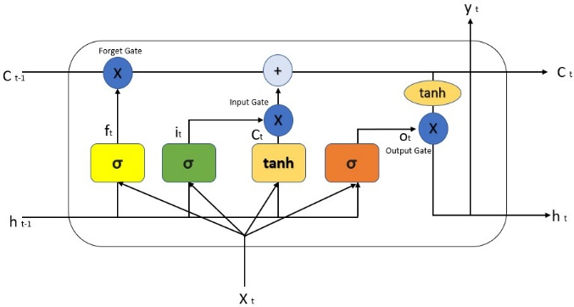

A cell vector value is preserved at each stage in the LSTM architecture. With LSTM, a clear gating procedure is applied. Three binary gates—the input gate (it), forget gate (ft), and output gate—make up an LSTM (ot). The memory cell in-process update is controlled by the input gate, the memory cell's reset to zero is controlled by the forget gate, and the memory cell's information flow visibility output is controlled by the output gate.

𝑓𝑡 = σ (𝑊𝑓. [ℎ𝑡−1, 𝑥𝑡]) + 𝑏𝑓 [18].

A description of the parameters of the LSTM shown in down Table.

|  |  |
| --- | --- |
| Parameter | Description |
| wf | Weight vector of the forget gate layer |
| ℎ𝑡−1 | The previously hidden state vector |
| ℎ𝑡 | Output hidden state vector |
| 𝑥𝑡 | Current input vector |
| 𝑏𝑓 | Bias vector |
| 𝑖𝑡 | Current input vector |
| 𝑜𝑡 | Output vector |
| 𝑐𝑡 | Output cell memory vector |
| 𝑐𝑡-1 | Output cell memory vector |
| 𝑐𝑡 | Output cell memory vector |

The researcher concludes from the LSTM results that the word insertion strategy is ideal for aspect-based sentiment analysis. The suggested LSTM model categorized consumer product evaluating sentences as highly negative, negative, positive, and amazingly positive instead of categorizing them as positive and negative. Using training data, the LSTM model has an accuracy of 93%, while with test data, it has an accuracy of 82%.

The default LSTM parameters used as the models' parameters in this investigation. Training the size of the input embedding layer with 64 and 128 results in an analysis of the suggested model's performance. For input on three benchmark data sets, this model provides greater accuracy for the length of the 280-word embedding vector. The memory unit is utilized to retain the words from the input used for the sentence evaluation. The suggested LSTM is built with 1192 memory units that can retain words in order to comprehend lengthy review paragraphs. The output layer chooses three nodes (positive, negative, and neutral) to provide a sentiment score [19].

# 1.6 Recommendation Systems

There are three techniques of recommendation systems: collaborative, content-based, and hybrid-based. The content-based method relies on the relationship between an item's description and the user's profile; item suggestions are made in accordance with the user's preferences. The collaborative method examines shared preferences across individuals by analyzing user behavior and preferences [20, 21]. The hybrid strategy combines the two approaches.

A rule-based recommendation system, also known as a content-based recommendation system, employs a set of predetermined rules to provide recommendations to users. Recommendation systems using rules can be straightforward and simple to use.

Based on well-defined rules created by the system designers. These guidelines might be founded on a variety of user or item data, including user demographics, item ratings, item genres, or other traits. For instance, a user may receive song recommendations via a rule-based recommendation system for a music streaming service based on the user's age, gender, and listening preferences.

The fact that rule-based recommendation systems are reasonably easy to comprehend, and use is one of its key advantages. Although they do not involve the use of sophisticated machine learning methods, they may also be rather quick. They may, however, be rigid and unable to adjust to shifting user preferences or newly added items in the suggestion database.

In general, rule-based recommendation systems can be a helpful tool for giving users recommendations, but they might not be as good at capturing the complexity of user preferences and the connections between various items in the recommendation database as other types of recommendation systems, like collaborative filtering or matrix factorization-based systems.

Table 2

Sentiments According Sentiment values

|  |  |
| --- | --- |
| Sentiment Range | Sentiment Level |
| -2 to -3 | Extreme negative |
| -0.5 to -2 | Negative |
| -0.5 to +0.5 | Neutral |
| +0.5 to +2 | Positive |
| +2 to +3 | Extreme positive |

# V**.** EXPERIMENTAL EVALUATION

# 1. LSTM models and Recommended system results

At this stage, we consider a variety of classification techniques to build the prediction model and determine the chance that a user would experience depression. We used 80% of the dataset for training, while the remaining 20% used for testing. The collection is divided into sections based on social media sessions, and each section contains all of the tweets from that session. Every tweet is assigned to one of two classes: depressed or non-depressive. Long-term memory and short-term memory are the classifiers utilized in the mode's development (LSTM). The LSTM model's parameters include an embedding layer, a dropout layer, an LSTM layer, and a dense layer with a SoftMax activation function

Parameters using LSTM model.

For evaluating the performance of the above-mentioned approaches, we used the following evaluation metrics: i) Accuracy ii) Precision iii) Recall iv) F1 Score [13].

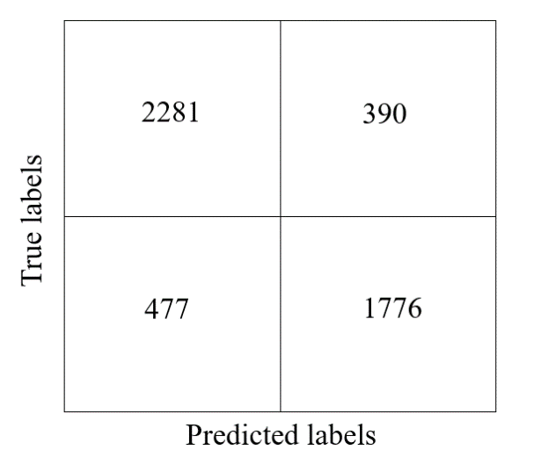

Confusion Matrix

i) Accuracy = TP + TN / TP + TN + FP +FN

ii) Precision = TP / TP + FP

iii) Recall = TP / TP + FN

iv) F1 Score = 2*{(recall * Precision) / *(recall + Precision)}

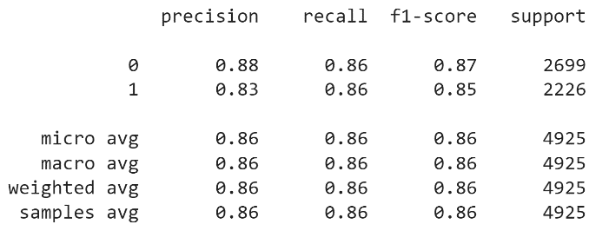

The experiments evaluated by using test data, we got 82% accuracy.

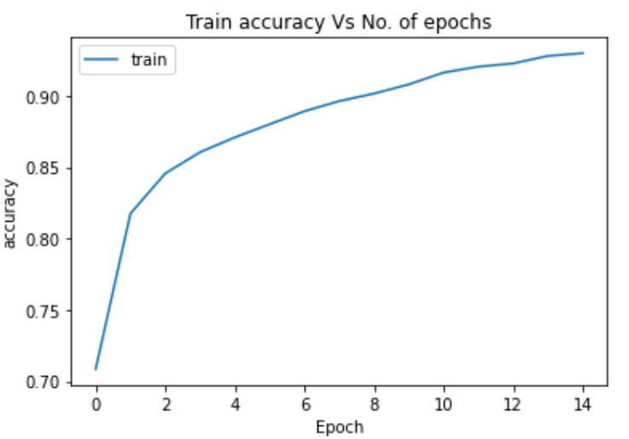

Train accuracy and Epochs

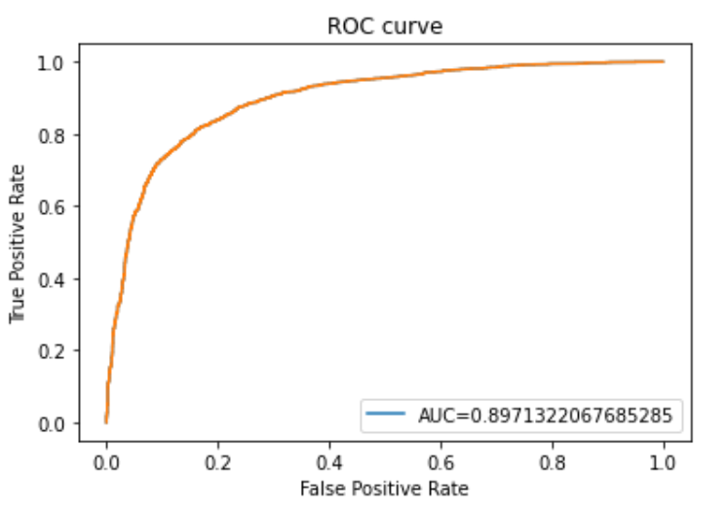

ROC and AUC curve

# V**.** CONCLUSION

In conclusion, sentiment analysis using long short-term memory (LSTM) models is a powerful and widely used technique for analyzing and understanding the sentiment of text data and user depression in individuals. And the recommended system gives a basis relaxion with music.

However, it is important to note that sentiment analysis and recommended system is not a replacement for professional diagnosis and treatment. It is recommended that individuals who may be experiencing depression seek the help of a qualified healthcare professional.

Overall, this models offer a powerful and effective approach for performing sentiment analysis in a music recommendation system, and they are likely to continue to play a major role in this field in the future.

# REFERENCES

1. Piyush Kumar, Poulomi Samanta, Suchandra Dutta, `Moumita Chatterjee and Dhrubasish Sarkar, “Feature Based Depression Detection from Twitter Data Using Machine Learning Techniques” The Banaras Hindu University, Volume 66, Issue 2, 2022.
2. R. L. Rosa, D. Z. Rodríguez, and G. Bressan, “SentiMeter-Br: a new social web analysis metric to discover consumers' sentiment,” in Proc. IEEE International Symposium on Consumer Electronics, Hsinchu, Taiwan, pp. 153-154, Jun. 2013.
3. R. L. Rosa, D. Z. Rodriguez, and G. Bressan, “Music recommendation system based on user s sentiments extracted from social networks,” in Proc. IEEE International Conference on Consumer Electronics, Las Vegas, USA, pp. 408-409, Jan. 2015.
4. Abdul Hasib Uddin, Durjoy Bapery, Abu Shamim Mohammad Arif, “Depression Analysis from Social Media Data in Bangla Language using Long Short Term Memory (LSTM) Recurrent Neural Network Technique”, InternationalConferenceonComputer,Communication,Chemical,MaterialsandElectronicEngineering(IC4ME2),11-12July,2019
5. Ms.R.Monika, dr.S.Deivalakshmi, Dr.B.Janet, “Sentiment Analysis of US Airlines Tweets using LSTM/RNN”, 9th InternationalConference onAdvancedComputing 2019.
6. Wang, Xinyu, Chunhong Zhang, Yang Ji, Li Sun, Leijia Wu, and Zhana Bao. ”A depression detection model based on sentiment analysis in microblog social network.” In Pacific-Asia Conference on Knowledge Discovery and Data Mining, pp. 201-213. Springer, Berlin, Heidelberg, 2013.
7. YukunMa, HaiyunPeng, TahirKhan, ErikCambria1, AmirHussain, “SenticLSTM:aHybridNetworkforTargetedAspect-BasedSentiment Analysis”, Springer Science+BusinessMedia,LLC,partofSpringerNature2018.
8. Renata Lopes Rosa, Gisele Maria Schwartz, Wilson Vicente Ruggiero, and Dem´ostenes Zegarra Rodr´ıguez, “A Knowledge-Based Recommendation System That Includes Sentiment Analysis and Deep Learning”, IEEE TRANSACTIONS ON INDUSTRIAL INFORMATICS, VOL. 15, NO. 4, APRIL 2019.
9. Renata L. Rosa, Demóstenes Z. Rodríguez, and Graça Bressan, “Music Recommendation System Based on User’s Sentiments Extracted from Social Networks”, IEEE Transactions on Consumer Electronics, Vol. 61, No. 3, August 2015.
10. Sudhanshu Kumar, Kanjar De, and Partha Pratim Roy, “Movie Recommendation System Using Sentiment Analysis From Microblogging Data”, IEEE TRANSACTIONS ON COMPUTATIONAL SOCIAL SYSTEMS, VOL. 7, NO. 4, AUGUST 2020.
11. D. F. Gurini, F. Gasparetti, A. Micarelli, and G. Sansonetti, “A sentiment-based approach to twitter user recommendation.” RSWeb@ RecSys, vol. 1066, 2013.
12. I. Om Prabha and G. U. Srikanth, “Survey of Sentiment Analysis Using Deep Learning Techniques.”
13. S. Cahyaningtyas, D. Hatta Fudholi, and A. Fathan Hidayatullah, “Deep Learning for Aspect-Based Sentiment Analysis on Indonesian Hotels Reviews,” Kinetik: Game Technology, Information System, Computer Network, Computing, Electronics, and Control, Aug. 2021, doi: 10.22219/kinetik.v6i3.1300.
14. W. Wang, S. J. Pan, D. Dahlmeier, and X. Xiao, “Recursive Neural Conditional Random Fields for Aspect-based Sentiment Analysis,” Mar. 2016, [Online].Available: <http://arxiv.org/abs/1603.06679>
15. L. Zhao and A. Zhao, “Sentiment analysis based requirement evolution prediction,” Future Internet, vol. 11, no. 2, 2019, doi: 10.3390/fi11020052.
16. M. Thomas and L. C.A, “Sentimental analysis using recurrent neural network,” Int. J. Eng. Technol., vol. 7, no. 2.27, p. 88, 2018.
17. P. Liu, X. Qiu, and H. Xuanjing, “Recurrent neural network for text classification with multitask learning,” IJCAI Int. Jt. Conf. Artif. Intell., vol. 2016–January, pp. 2873–2879, 2016.
18. A. Hassan and A. Mahmood, “Deep Learning approach for sentiment analysis of short texts,” 2017 3rd Int. Conf. Control. Autom. Robot. ICCAR 2017, pp. 705–710, 2017.
19. Diki Wahyudi, Yuliant Sibaroni, “Deep Learning for Multi-Aspect Sentiment Analysis of TikTok App using the RNN-LSTM Method,” Building of Informatics, Technology and Science (BITS) Volume 4, No 1, Juni 2022 Page: 169−177
20. D. Yang, and W. Lee, "Music emotion identification from lyrics," in Proc. IEEE International Symposium on Multimedia, San Diego, California, USA, pp. 624-629, Dec. 2009.
21. G. Qiu, F. Zhang, J. Bu, and C. Chen, “Domain specific opinion retrieval,” in Proc. Asia Information Retrieval Symposium on Information Retrieval Technology, Sapporo, Japan, pp. 318-329, Oct. 2009.